Princess Sumaya University for Technology
King Abdullah II Faculty of Engineering
Electrical Engineering Department



Embedded Systems NO. 22442
Final Project

Authors:
Yacoub Yousef | 20220063 | NIS
Omar Al-Shamali | 20220229 | NIS
Talal Barakat | 20221026 | Computer Engineering
January 14, 2026
Contents
Abstract 3
Introduction and Background 3
Hardware Design 4
Mechanical Design 4
Electrical Design 4
Motor Configuration 4
H-Bridge Motor Driver 5
Power Supply and Switching 5
Voltage Regulation 5
Pin Mapping and Hardware Connections 6
Software Operation and Track Navigation 6
Start Zone 7
Mode 0: Line-Following Zone and T-Junction Handling 7
Mode 1: Tunnel Zone 7
Mode 2: Path Navigation and Obstacle Avoidance Zone 7
Mode 3: Hallway Navigation and Parking 8
Problems and Recommendations 9
Conclusion 9

Abstract
This project shows the design and implementation process of an autonomous four-wheel drive (4WD) mobile robot for the Embedded Systems Autonomous Mobile Robots Challenge. The main goal of this robot is the autonomous navigation of a multi-zone track consisting of line-following parts, a tunnel, obstacle avoidance, a bump, and finally a parking zone. The mobile robot is developed using a 4WD Chassis and a system of four DC motors that can be controlled using an H-bridge motor driver and a regulated power source from a battery. The hardware design is mainly focused on ensuring a stable motor control, safe power management, and operates reliably across various environmental conditions. The completed prototype successfully integrates mechanical and electrical subsystems to achieve autonomous navigation while meeting the project constraints and design requirements.

Introduction and Background
Autonomous mobile robots are one of the primary themes of the study of embedded systems and robotics education as they represent a combination of mechanical engineering, electronic integration, and control theory into a single, functional device. The current project involved the design and construction of this kind of robot to compete in the Autonomous Mobile Robots Challenge, which is an activity that is in line with the objectives of the Embedded Systems curriculum. The challenge requires independent navigation through a specified, multi-zoned map that will require completing all of the stages with precision and effectiveness.

The competition course is divided into a sequence of following sections, which include a line-following section, a dark tunnel, an obstacle-filled path-finding section, bump, and a final parking section. These zones have different environmental and working variables, which strictly test the autonomous navigation functions of the robot in different and uncontrollable conditions.

Hardware Design

Mechanical Design
The robot is based on a four-wheel drive (4WD) chassis with DC motors. Each DC motor is fixed directly to the chassis and connected to a wheel, which provides better traction, torque, and stability compared to two-wheel-drive (2WD). The 4WD system is capable of making tighter turns and handling uneven surfaces, which is important for reliable line following.
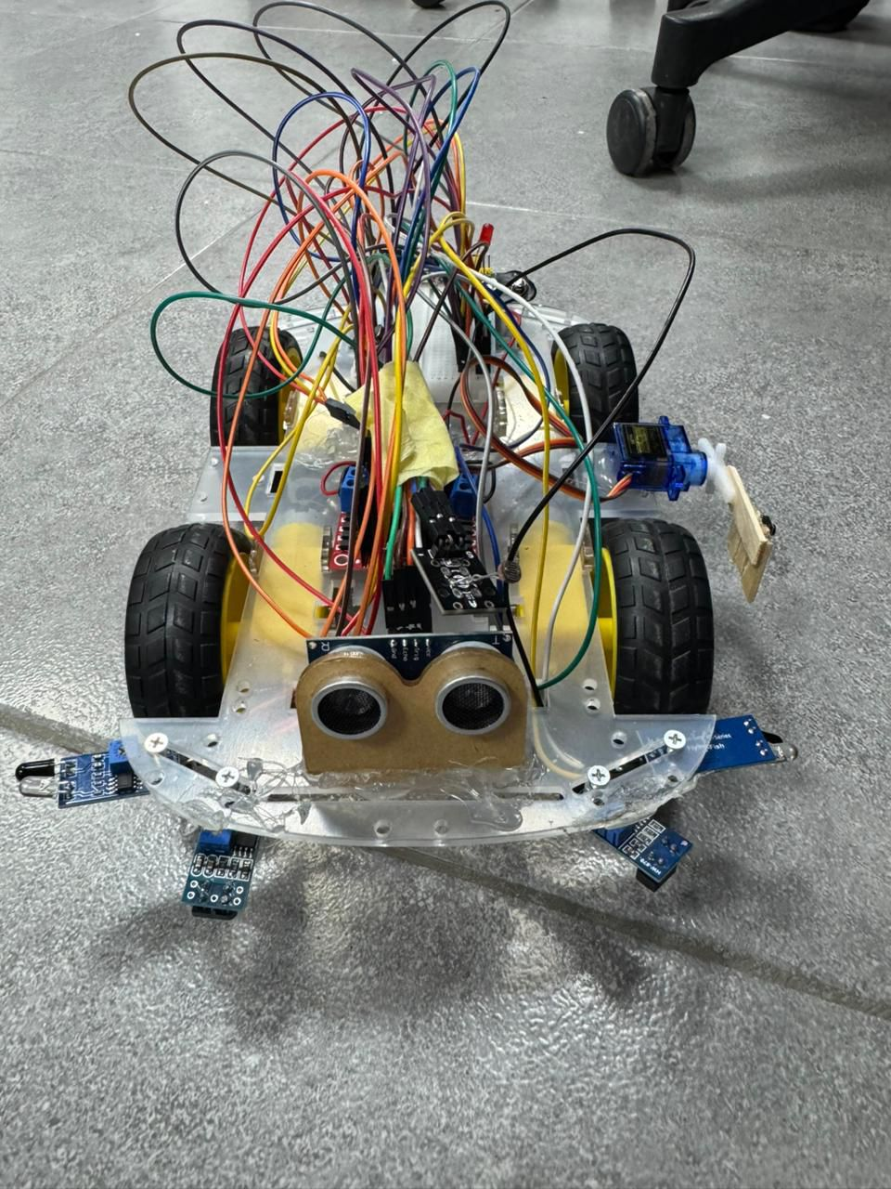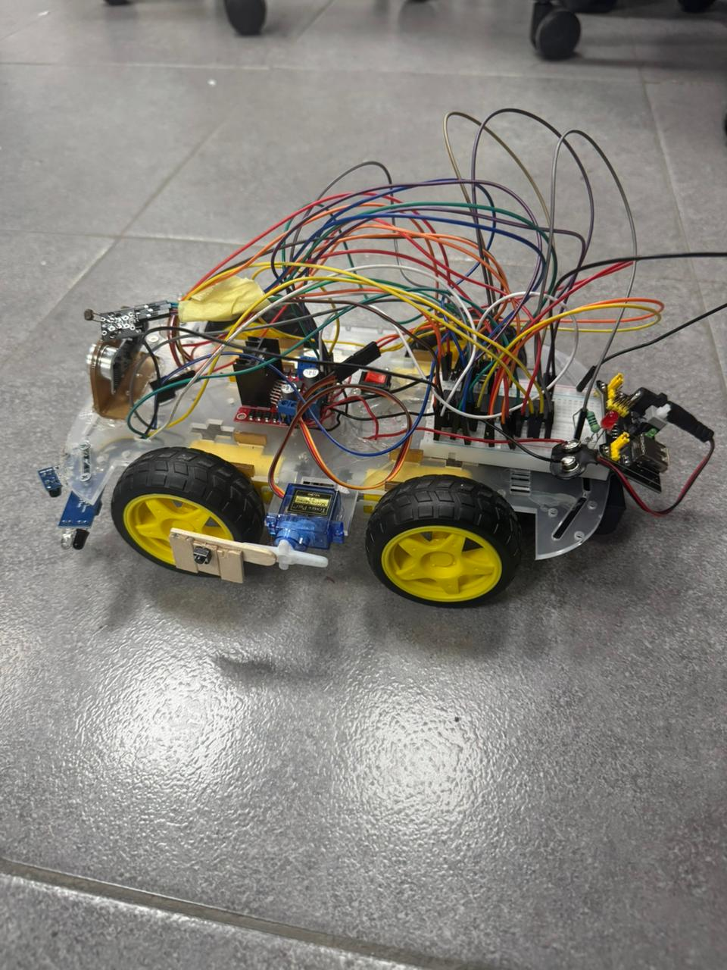

Electrical Design
The electrical design focuses on motor control, power, and system safety.

Motor Configuration
It uses a total of four DC motors. In order to provide control simplicity while ensuring sufficient torque is produced, the motors are coupled together in pairs:

- The two motors on the left side are electrically connected.
- The two right-side motors are electrically connected.

Each motor pair is electrically connected in parallel, providing two different motor outputs:

- An output corresponding to the left motors
- An output for the right motors

These outputs connect with an H-bridge motor driver, allowing for independent control of left and right wheels for forward movement, turning and stopping.

H-Bridge Motor Driver
An H-bridge motor driver is used to control the speed and direction of motors. Both motor connections are directly linked to the H-bridge motor driver output terminals. This allows the following:

- Forward and Reverse Rotation
- Differential steering (turning left or right)
- Separation between high-current motor paths and control electronics.

Power Supply and Switching
The robot is powered by a battery, which provides energy for both the motors and control systems of the robot. A power switch is used to ensure safe on/off control of the power to the system.

The power connections are arranged as follows:

- The GND of the battery is directly connected to the ground terminal in the H-bridge.
- The positive terminal of the battery is connected to the “0” input terminal of the power switch.
- The output terminal of the switch is connected to the positive supply input of the H-bridge.

This provides a means whereby the motors are supplied with power only when the switch is activated; hence, the process is safe.

Voltage Regulation
A voltage regulator is used in order to stabilize the voltage supply to the control circuitry. The wiring configuration is as follows:

- The ground terminal of the voltage regulator is connected to the common ground of the H-bridge.
- The positive terminal of the voltage regulator is linked to the positive output terminal of the power switch.

It ensures that both the motor driver and the regulated logic supply share a common ground reference but at appropriate voltage levels for components such as the microcontroller and the sensors. This prevents voltage fluctuations from the motors from affecting the microcontroller and sensors.

Pin Mapping and Hardware Connections

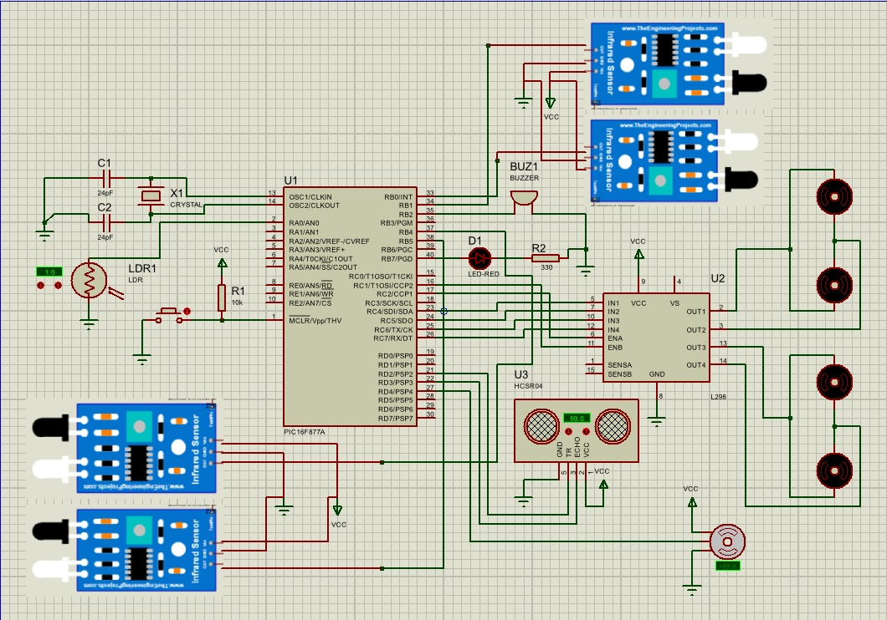

Software Operation and Track Navigation
The software controls the robot’s behavior using a time-based and state-driven structure that enables autonomous navigation across the multi-zone track. Sensor inputs and timing conditions are continuously evaluated to determine the robot’s motion and transitions between operating zones.

Start Zone
After the switch is flicked, the robot then begins an initialization sequence in which a hardware timer causes a three second delay precisely. After this period, An LED indicator is then switched on, to signal the entering into of an active driving mode. The robot then begins moving forward and briefly applies a speed boost to ensure a smooth and stable entry into the line-following zone.

Mode 0: Line-Following Zone and T-Junction Handling
After the start sequence, the robot operates in line-following mode using two-line sensors mounted at the front of the robot. These sensors distinguish between the black line and the background of the track which is white. The code continuously adjusts the motor speeds based on the sensor readings to keep the robot centered on the line. Straight motion is maintained when both sensors detect the white surface, but when one sensor detects the black line, corrective steering is applied to return the robot to the center of the track.This logic enabled the robot to navigate curves and straight lines.
A T-junction is detected when both sensors detect black lines at the same time in this current mode, indicating that there is an intersection. When this condition is detected, the software triggers a pre-programmed turn left 90 degrees function. This design allows the robot to go through the only pass the intersection well without problems.

Mode 1: Tunnel Zone
While performing line following, the robot will continuously monitor the light intensity through a light-dependent resistor (LDR). A decrease in light level is perceived to be an entry into the tunnel zone. When the condition is met, the buzzer will be activated. The robot continues line following while the buzzer is active. Once the LDR detects normal light again, the buzzer is deactivated and the system transitions to the next state.

Mode 2: Path Navigation and Obstacle Avoidance Zone
When leaving the tunnel, the robot entered the area of line-free path navigation and switched to the mode of ultrasonic-based navigation. The robot then moved forward until it sensed a wall at an estimated distance of 25 cm and made right turn to follow the path boundary.

The robot then continued straight onwards with the watch distance. If the sensor doesn’t identify an object in 4 seconds, it would keep moving forward till it reaches the wall then turns right, else if it identified an object in about 4 seconds, that could be an obstacle as opposed to a wall. The robot, therefore, turned to the right and then went ahead until it reached 25 cm from a wall before turning to the left and passing through the obstacle.

Having avoided this obstacle, the robot moved towards the direction of the goal until it started to sense a wall at a close distance. The robot took another right turn when it was detected and thus the obstacle navigation sequence was complete in the path zone.

Mode 3: Hallway Navigation and Parking
Once the obstacle avoidance area is finished, the robot then moves through the hallway area while it searches for the track line. Two IR wall sensors are installed in order to maintain the alignment of movement when the platform is moving forward, and line sensors are constantly monitored. To ensure reliable detection, the line must be sensed consistently before the robot confirms that it has reached the track.

When the line is detected, the platform switches to a final line-following behavior at a slower speed to be able to position accurately. Parking area is identified when the line is detected by both line sensors for a stable duration. After the parking marker is identified, the platform triggers the buzzer as a sound alarm and performs an automated parking maneuver. After completing the maneuver, the robot comes to a stop and raises a flag using a servo motor to signal task completion.

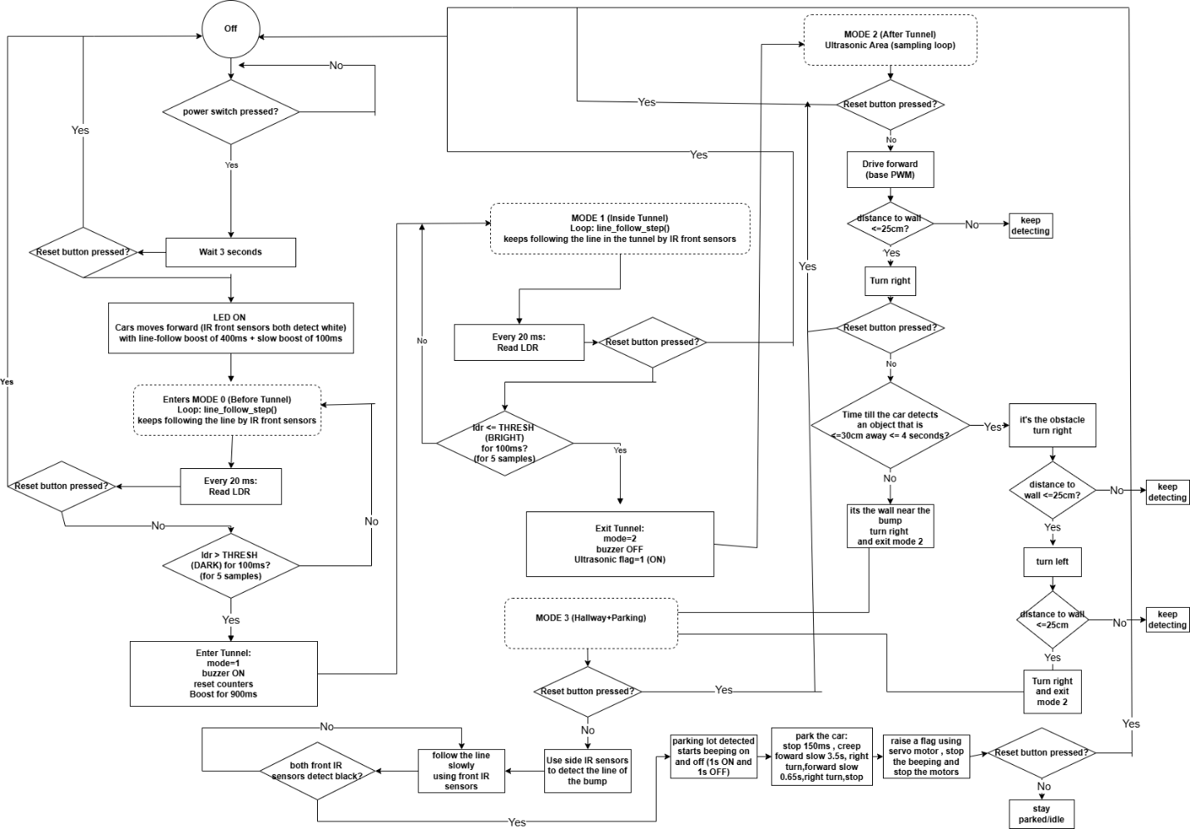

Problems and Recommendations
In the process of designing the autonomous mobile robot, many challenges were met which influenced both the process of hardware design and the process of system testing afterwards.

One of the major issues was a shift in the system with two-wheel drive (2WD) to a four-wheel drive (4WD). The 2WD platform was discovered to be insufficient in terms of traction and stability needed to support the mission needs especially during direction change or over rough track sections. It was decided to adopt 4WD arrangement which stabilized and controlled the car; however, it required a total redesign of the mechanical system and the connection between motors, extending the development time
The other challenge was that of limited background in assembling a machine and constructing the robot. The chassis construction, fine component placement and wiring routing required various repetitive process and trial-and-error modifications. As a result, much of the development time was spent to hardware integration. It could be recommended to provide students with instructional videos, in-depth assembly instructions, or a step-by-step manual on constructing it; these documents would significantly reduce the amount of time spent on setting it up and allow students to invest more in system design, and assessment.

Lastly, the testing procedures were not accurate due to the fact that the testing track continued to deteriorate with time. The wear and tear, especially of the line-following segment, meant poor sensor data and poor performance measurements. To address this issue, it is recommended to maintain the testing track regularly or provide multiple standardized tracks to ensure consistent and fair testing conditions.

Conclusion
This project successfully demonstrates the design and development of an autonomous mobile robot capable of moving along a multi-zone track. The project combines the design of a mechanical system, an electrical system, and software into a complete self-contained system that meets the needs of the Embedded Systems: Autonomous Mobile Robots Challenge. The introduction of the four-wheel-drive system improved the robot’s stability and agility. Sensor integration and the use of timers in the software ensured that the robot moves autonomously. The robot’s behavior is governed by a state-based embedded software architecture that processes sensor inputs and timing events to control navigation decisions across all track zones. This project provides relevant experience in robotics and problem-solving.

